

BIT4138 ADVANCED CRYPTOGRAPHY

RYAN NDERITU BSCCS/2024/42638

GitHub Repository: https://github.com/ryan30-tech/BIT-4138-advanced-cryptography

MAY 2026

Contents
PRACTICALS 3
Week 6: Hashing and Password Security 3
Implementation of Secure Hash Functions and Authentication 3
Fig 1: SHA-256 Hash Generation 3
Fig 2: Password Hashing System 3
Fig 3: Login Authentication Workflow 4
Fig 4: Hash Verification Results 5
Fig 5: Password Security Testing 5
Student Reflection 6

PRACTICALS

Week 6: Hashing and Password Security

Implementation of Secure Hash Functions and Authentication

Fig 1: SHA-256 Hash Generation
I was able to hash the message “Hunter123” using the SHA-256.
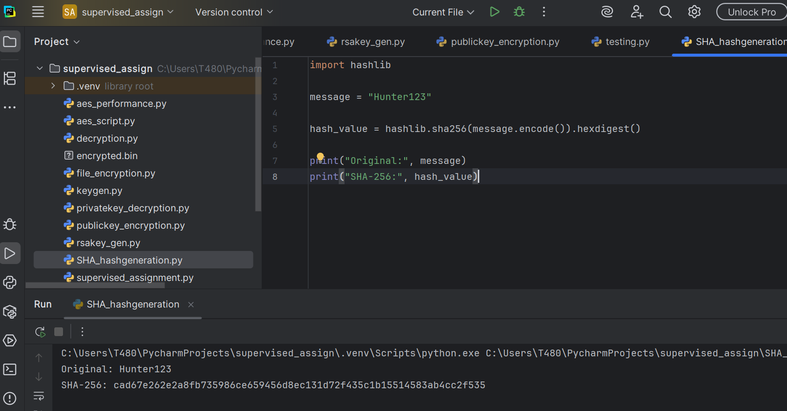

Fig 2: Password Hashing System
Here the system provides where the user enters their own password then the system hashes it.
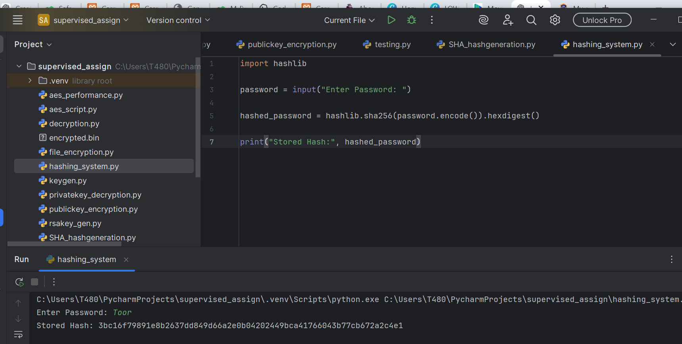

Fig 3: Login Authentication Workflow
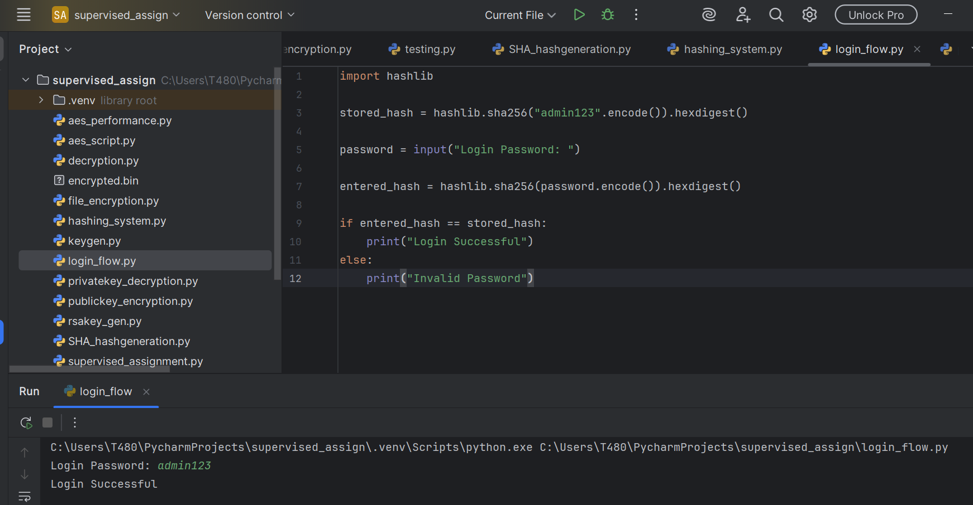
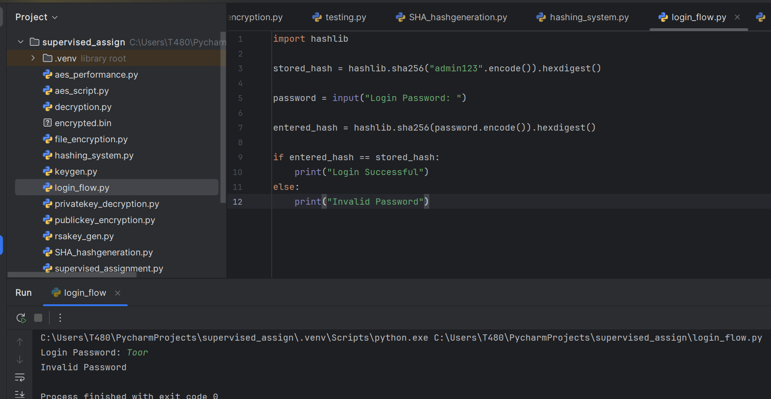
The two figures demonstrate where a user enters the correct password and login flow becomes successful but when they enter a different password the system flags it as invalid.

Fig 4: Hash Verification Results
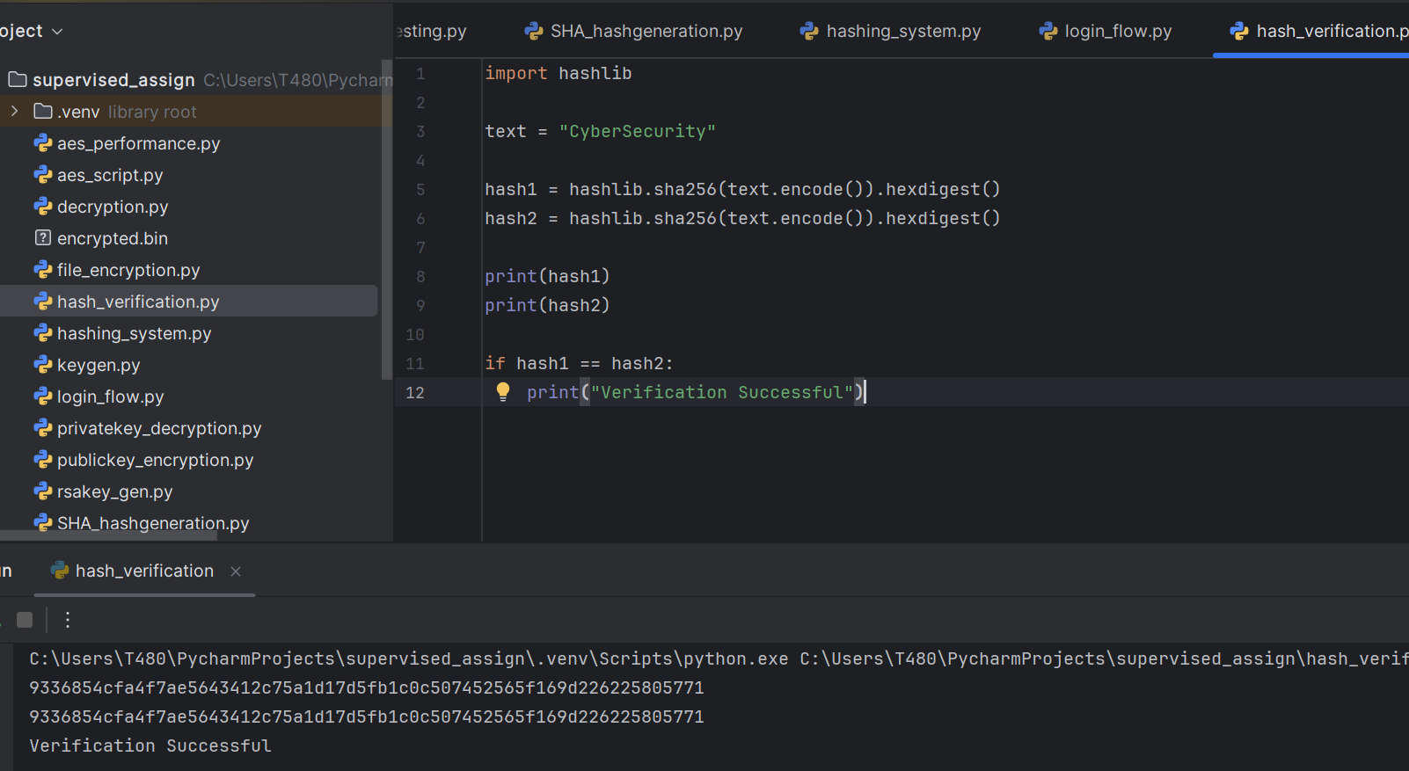
The verification works such that if the first and second hash created are similar with no errors then it is considered a success.

Fig 5: Password Security Testing
This test shows that no similar hashes are created for each word a unique hash is created.
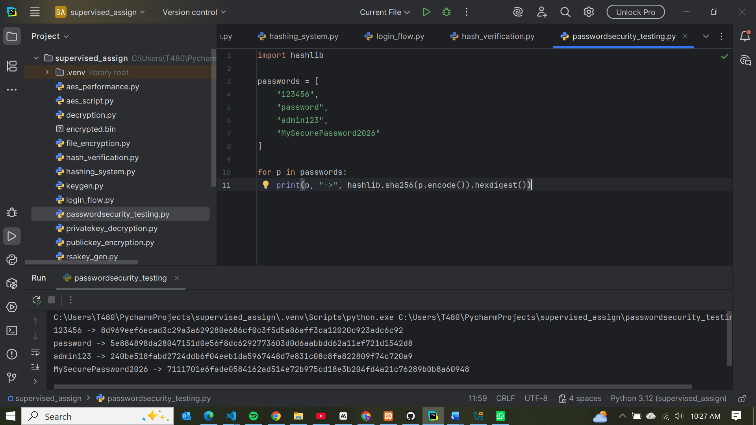

Student Reflection
SHA-256 hashing was implemented to secure passwords without storing plaintext values. Authentication was achieved through hash comparison during login. Testing demonstrated the irreversible nature of hashing and highlighted the importance of strong passwords in improving system security.

